**CSCE 5400 Formal Languages, Automata, and Computability - Fall 2024**

**Name:** Kishan Kumar Zalavadia

**EUID:** 11685261

**Assignment-4**

**Ans**:

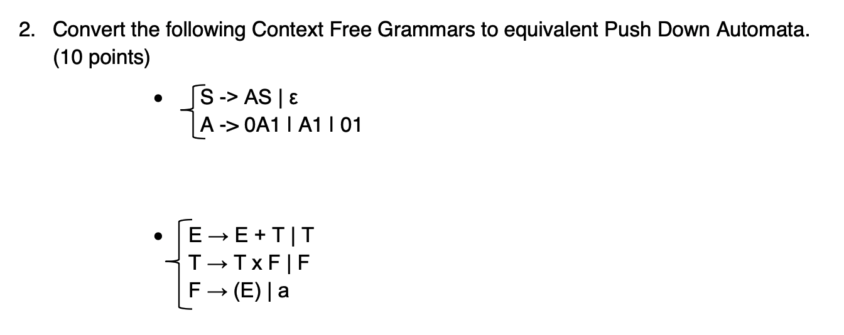

**Ans**:

**2a.**

**2b.**

